Jenkins Task- 01

Task Title
End-to-End Jenkins Setup, Security, User Management, Job Configuration, and GitHub Integration
Overall Task Objective:
The objective of this task is to install and configure Jenkins on an AWS EC2 instance, run Jenkins on a custom port, secure the Jenkins server, manage users with role-based access, configure node labels for controlled job execution, and create Jenkins jobs integrated with both public and private GitHub repositories. This setup ensures a secure, controlled, and scalable Continuous Integration environment.
Overall Tasks Prerequisites:
- AWS EC2 instance with Amazon Linux
- Java (Amazon Corretto 17) installed
- Jenkins installed and running
- SSH access to EC2 instance
- Open inbound port 8081 in Security Group
- Administrator access to Jenkins
- Git plugin installed in Jenkins
- GitHub account
- Access to a public and a private GitHub repository
- GitHub Personal Access Token (PAT) for private repository

Task Title
Installation and Configuration of Jenkins on AWS EC2 Instance on port number 8081.
Objective
The objective of this task is to set up a Jenkins Continuous Integration server on an AWS EC2 instance. This includes creating the required AWS infrastructure, installing necessary dependencies such as Java, configuring Jenkins services, changing the default port, and successfully accessing the Jenkins web interface for initial setup.
Prerequisites
- AWS account with required permissions
- Basic knowledge of AWS services (VPC, EC2, Security Groups)
- Amazon Linux EC2 instance
- SSH access to EC2 instance
- Internet connectivity
- Java 17 (Amazon Corretto)
- Open inbound port (8081) in EC2 security group
Steps to Install and Access Jenkins on AWS EC2
- Logged in to the AWS Management Console.
- Created a custom VPC named jenkins in the US East (N. Virginia) region.
- Verified that the VPC status was Available and DNS resolution was enabled.
- Navigated to the EC2 service and launched a new instance.
- Selected Amazon Linux as the operating system.
- Chose t3.micro instance type.
- Launched the instance and confirmed that it was in Running state with all status checks passed.
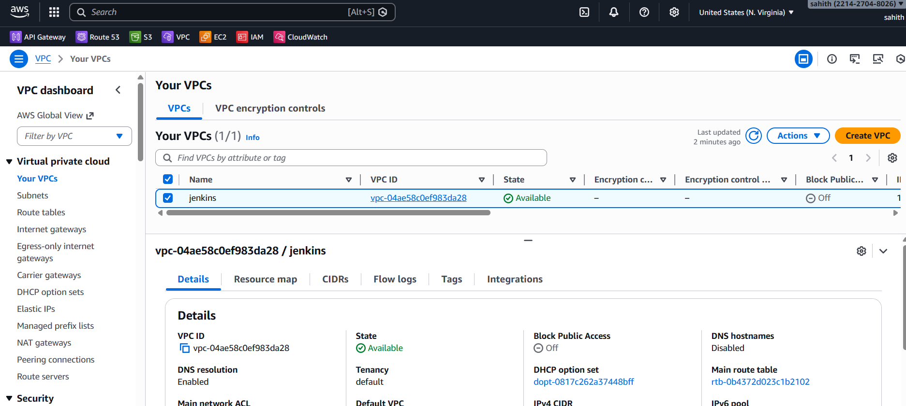
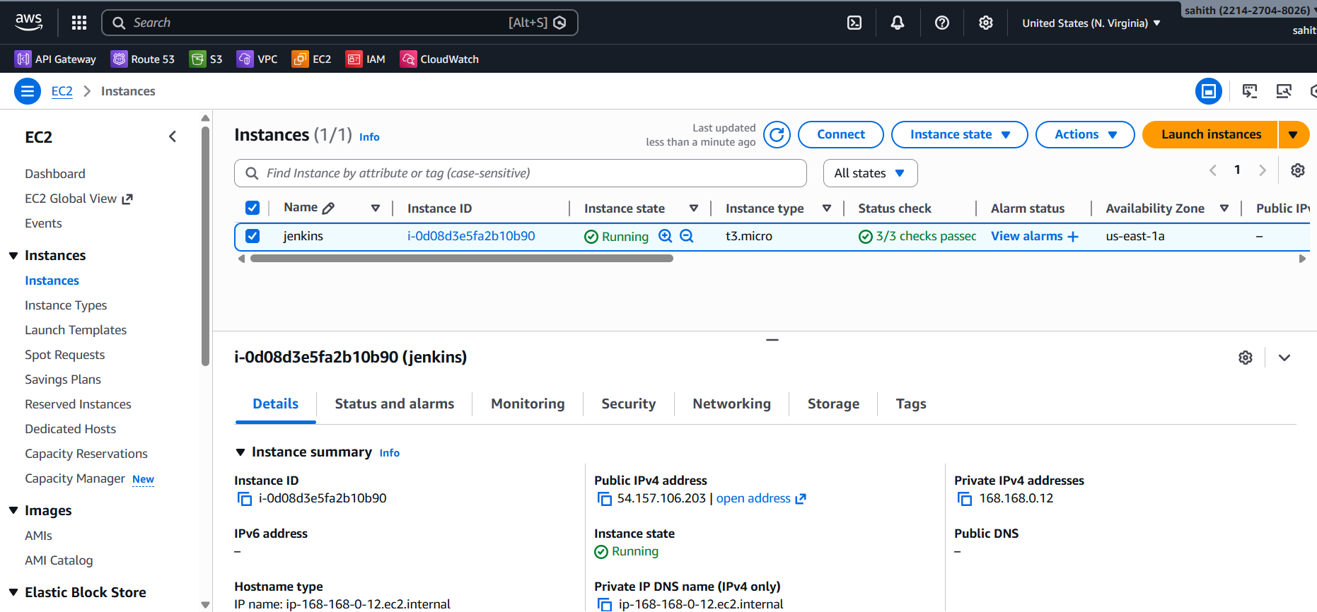
- Connected to the EC2 instance using SSH.
- Updated the system packages.
- Installed Java 17 (Amazon Corretto) required for Jenkins.
- Verified the Java installation.
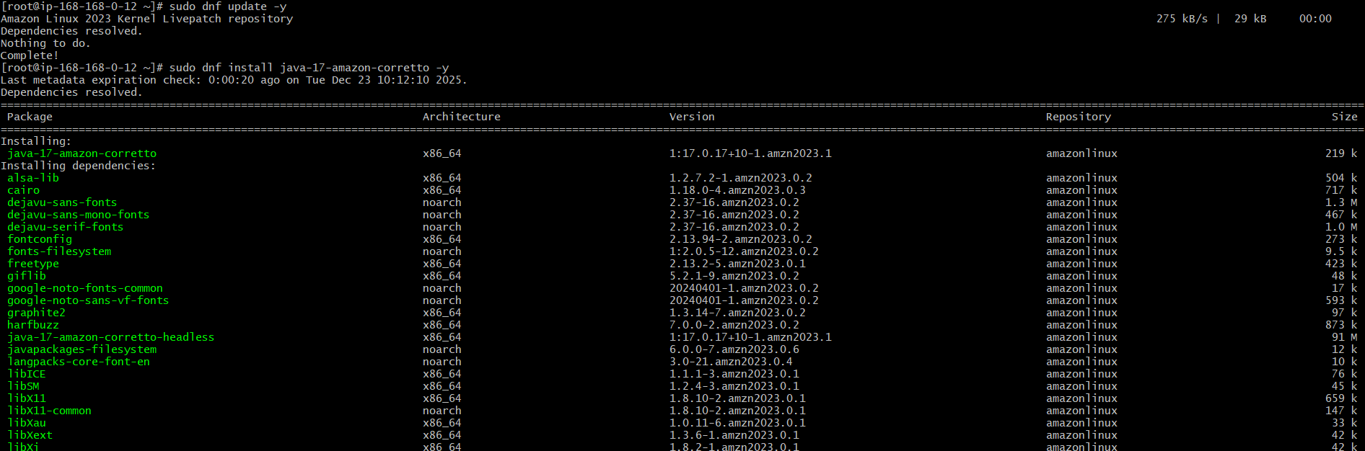
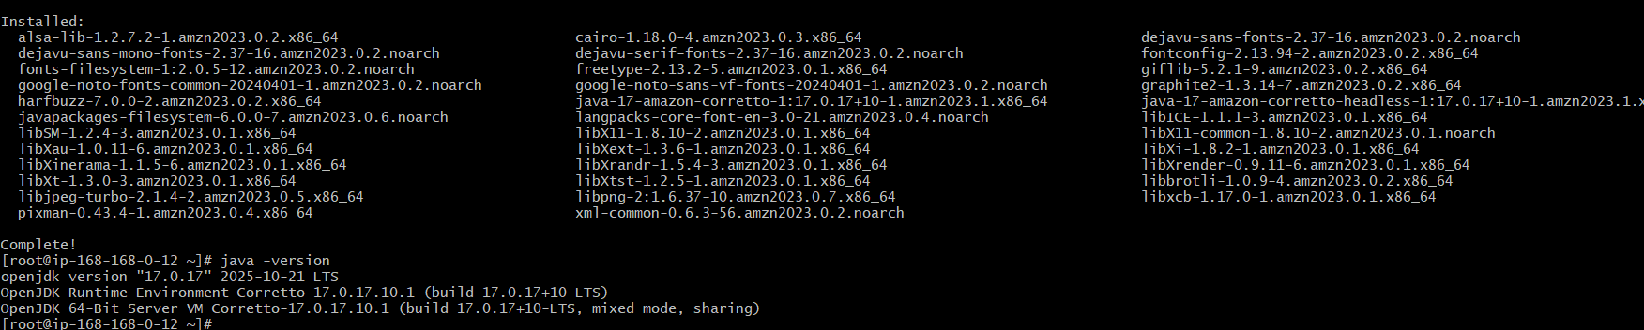
- Added the Jenkins repository to the system.
- Imported the Jenkins repository GPG key.
- Installed Jenkins successfully.
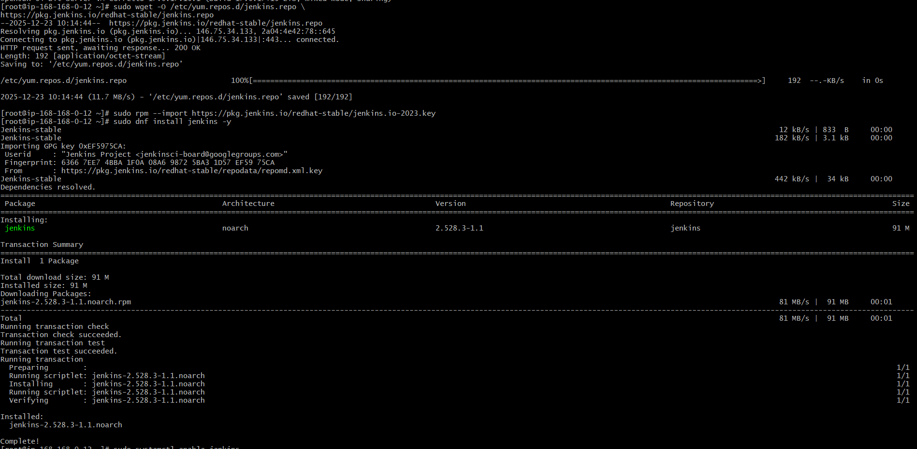
- Started the Jenkins service and verified that the service was running.
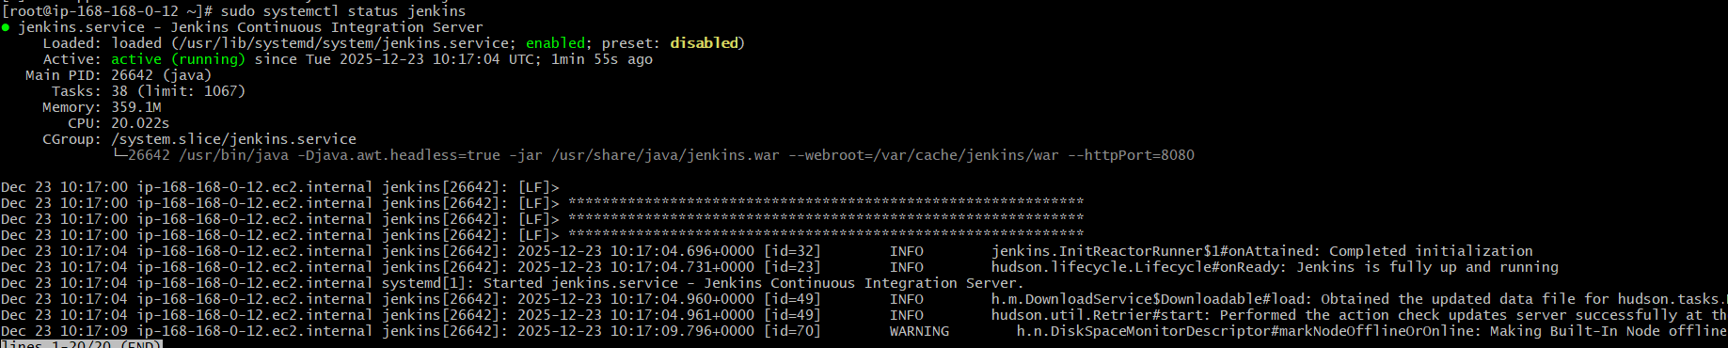
- Edited the Jenkins system service configuration file.
- Changed the Jenkins HTTP port from 8080 to 8081.
- Reloaded the system daemon and restarted the Jenkins service.
- Verified that Jenkins was running on the updated port.
- Opened a web browser and accessed Jenkins using the public IP address and port 8081.
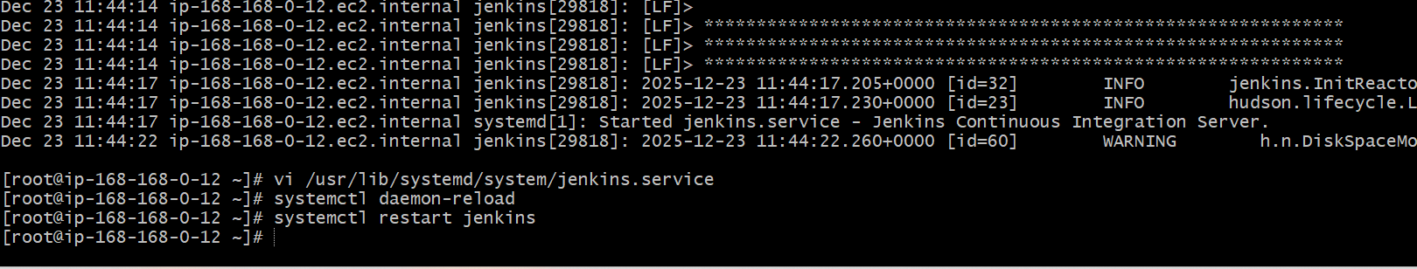
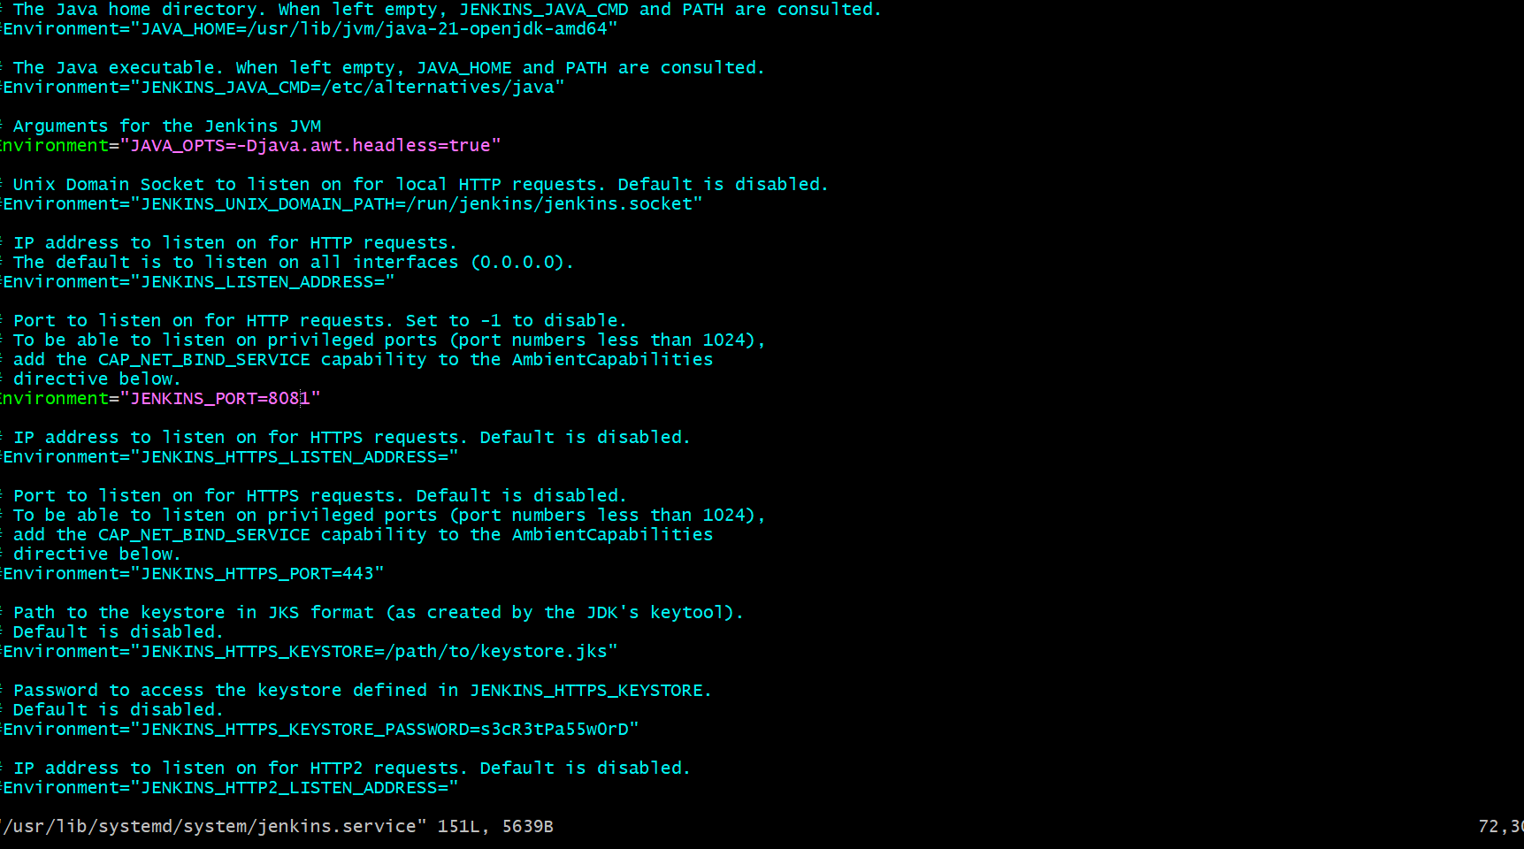
- Reached the Jenkins Unlock page.
- Identified the file location containing the initial administrator password for Jenkins.
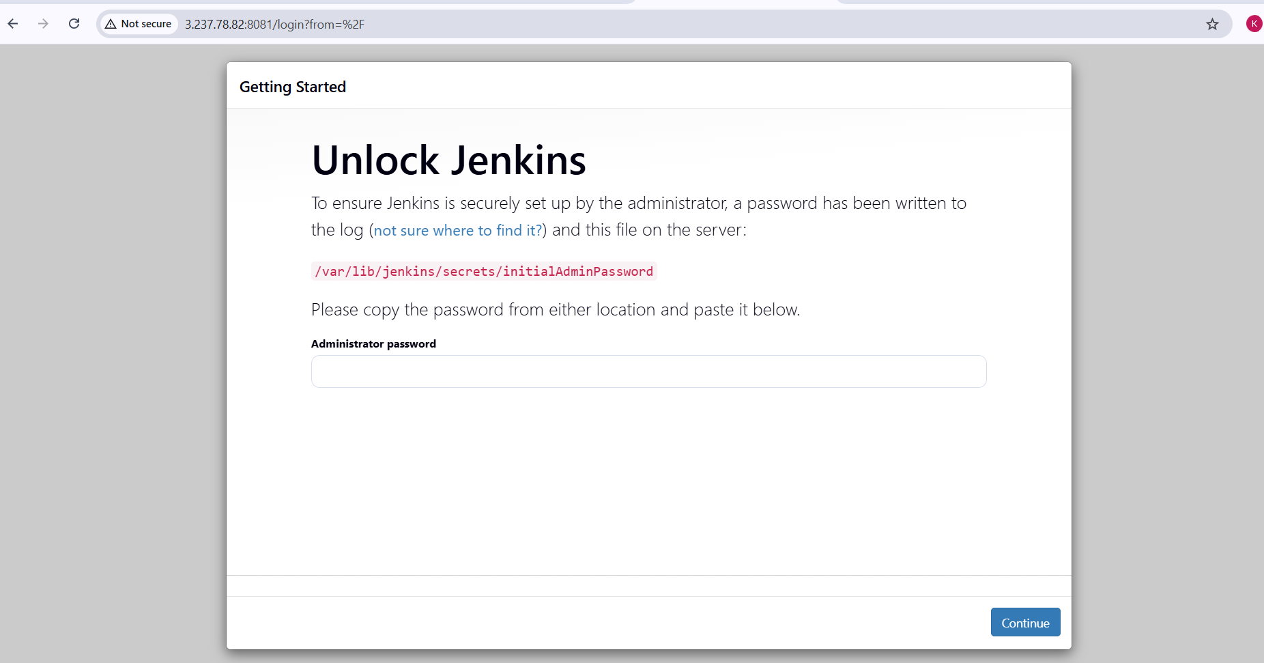
Validation Steps:
- Verified VPC status as Available
- Confirmed EC2 instance state as Running with 3/3 status checks passed
- Verified Java installation using version check
- Confirmed Jenkins service status as Active (Running)
- Validated Jenkins port change from 8080 to 8081
- Accessed Jenkins using browser via Public IP:8081
- Successfully reached the Jenkins Unlock screen
Conclusion
Jenkins was successfully installed and configured on an AWS EC2 instance. The required infrastructure was created, dependencies were installed, and the Jenkins service was customized to run on a non-default port. The Jenkins web interface was accessed successfully, confirming that the setup is complete and ready for further CI/CD pipeline configuration.

Task Title:
Secure Jenkins Server
Objective
The objective of this task is to securely configure a Jenkins server after installation. This includes unlocking Jenkins using the initial administrator password, installing recommended plugins, creating the first admin user, configuring the Jenkins instance URL, and verifying that the Jenkins setup is completed successfully and ready for use.
Prerequisites:
- AWS account
- Running EC2 instance with Jenkins installed
- Java installed on the EC2 instance
- Jenkins service running
- Open inbound port (8081) in EC2 Security Group
- Browser access to the Jenkins public IP
Steps Performed – Secure Jenkins Server
- Logged in to the Jenkins EC2 instance using SSH.
- Navigated to the Jenkins secrets directory:
  - /var/lib/jenkins/secrets
- Identified the file initialAdminPassword inside the secrets directory.
- Retrieved the Jenkins initial administrator password from the file.
- Opened a web browser and accessed Jenkins using:
  - http://<Public-IP>:8081
- Reached the Unlock Jenkins screen.
- Entered the initial administrator password.
- Clicked Continue to unlock Jenkins.
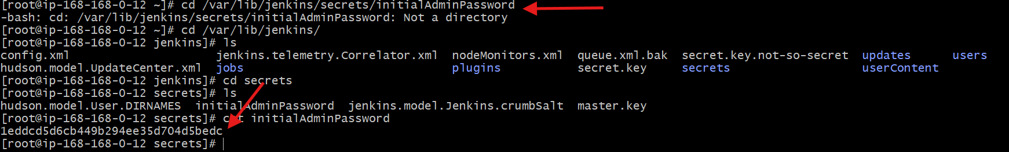

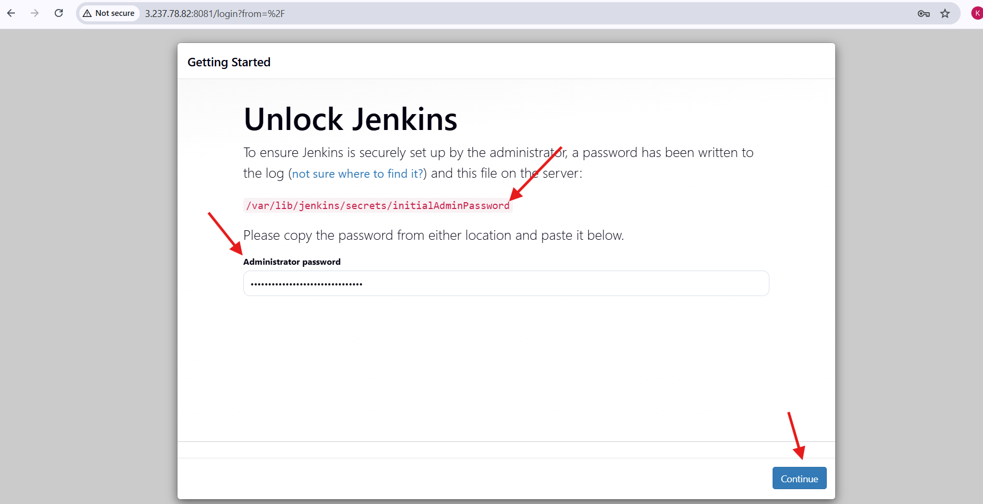
- Reached the Customize Jenkins screen.
- Selected Install suggested plugins.
- Waited for Jenkins to download and install the recommended plugins successfully.
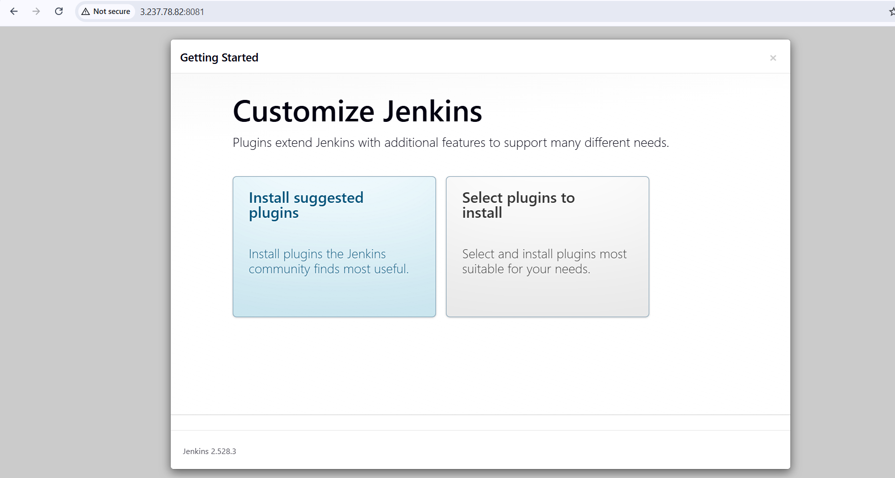
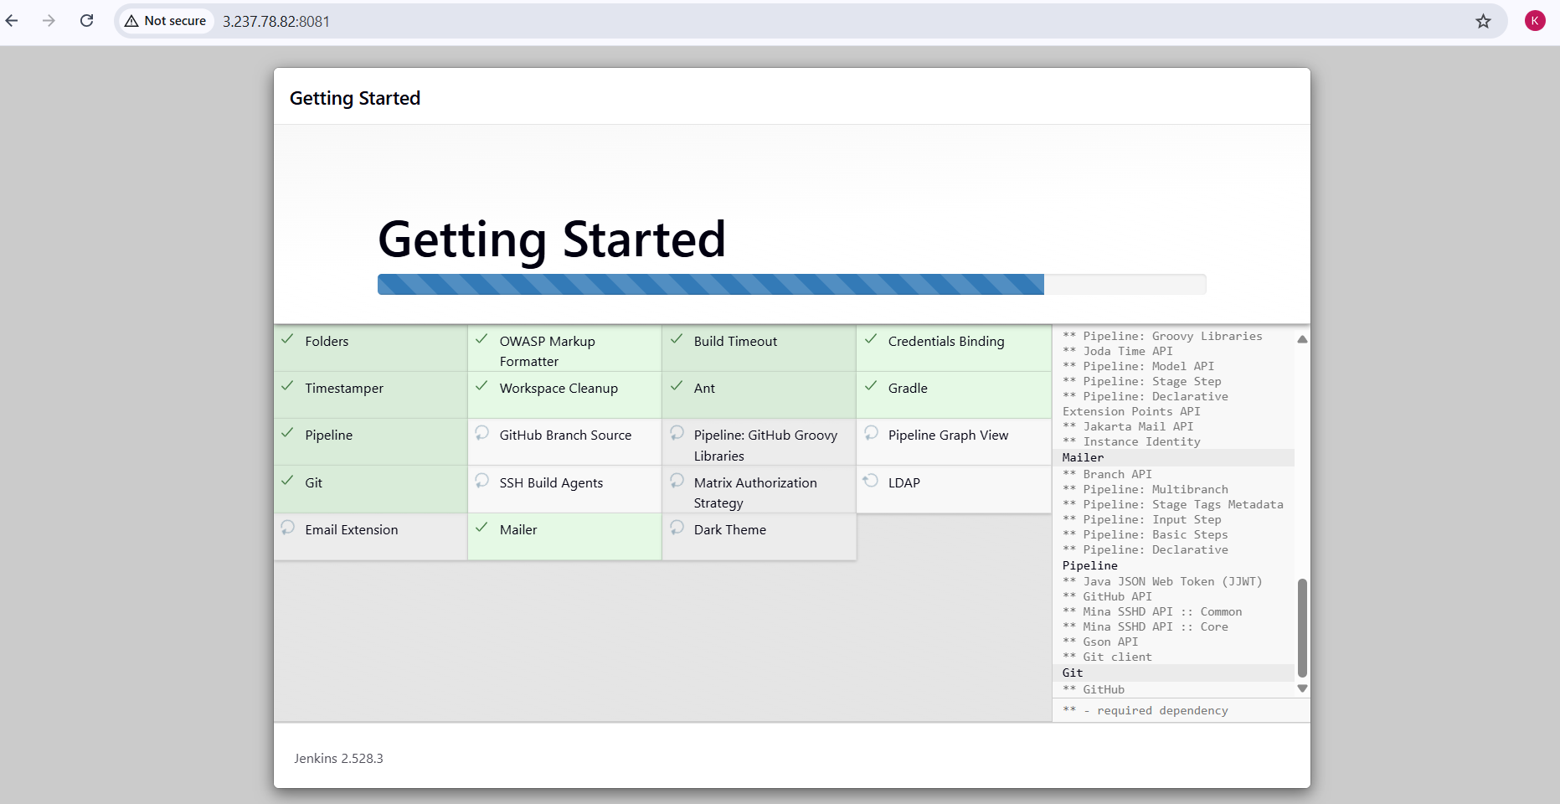
- Navigated to the Create First Admin User screen.
- Entered the administrator username.
- Set and confirmed the administrator password.
- Provided full name and email address.
- Clicked Save and Continue to create the admin user.
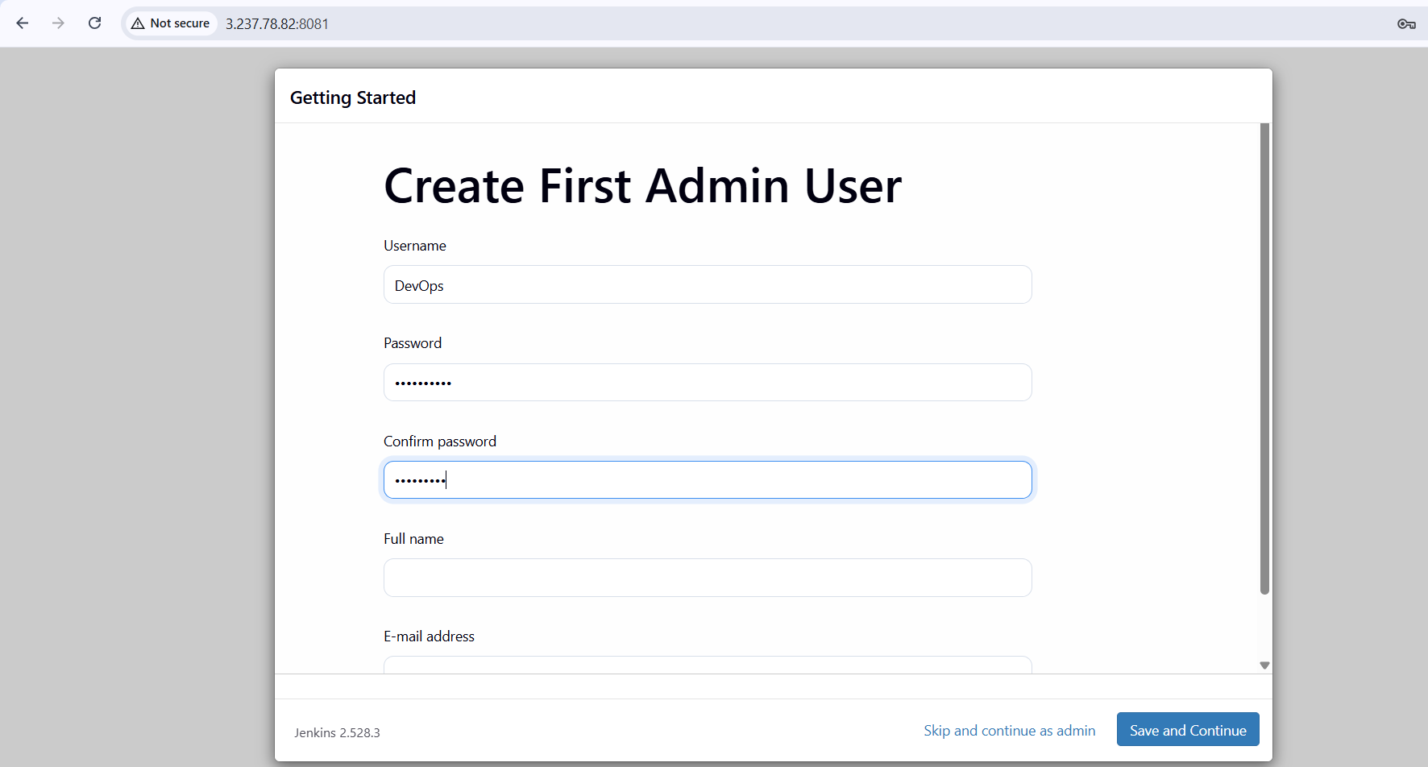
- Reached the Instance Configuration screen.
- Verified the Jenkins URL with the correct public IP and port.
- Clicked Save and Finish to complete configuration.
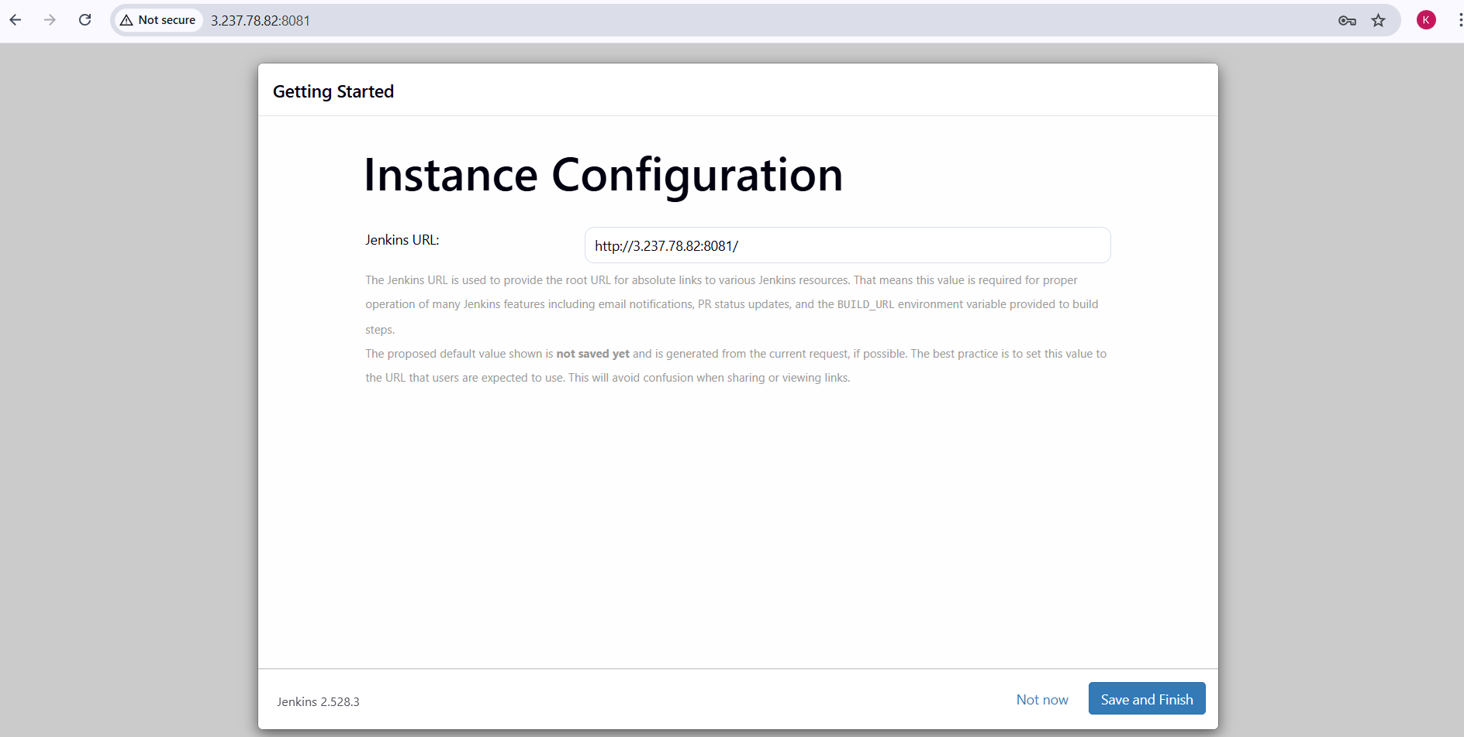
- Jenkins displayed the “Jenkins is ready!” confirmation screen.
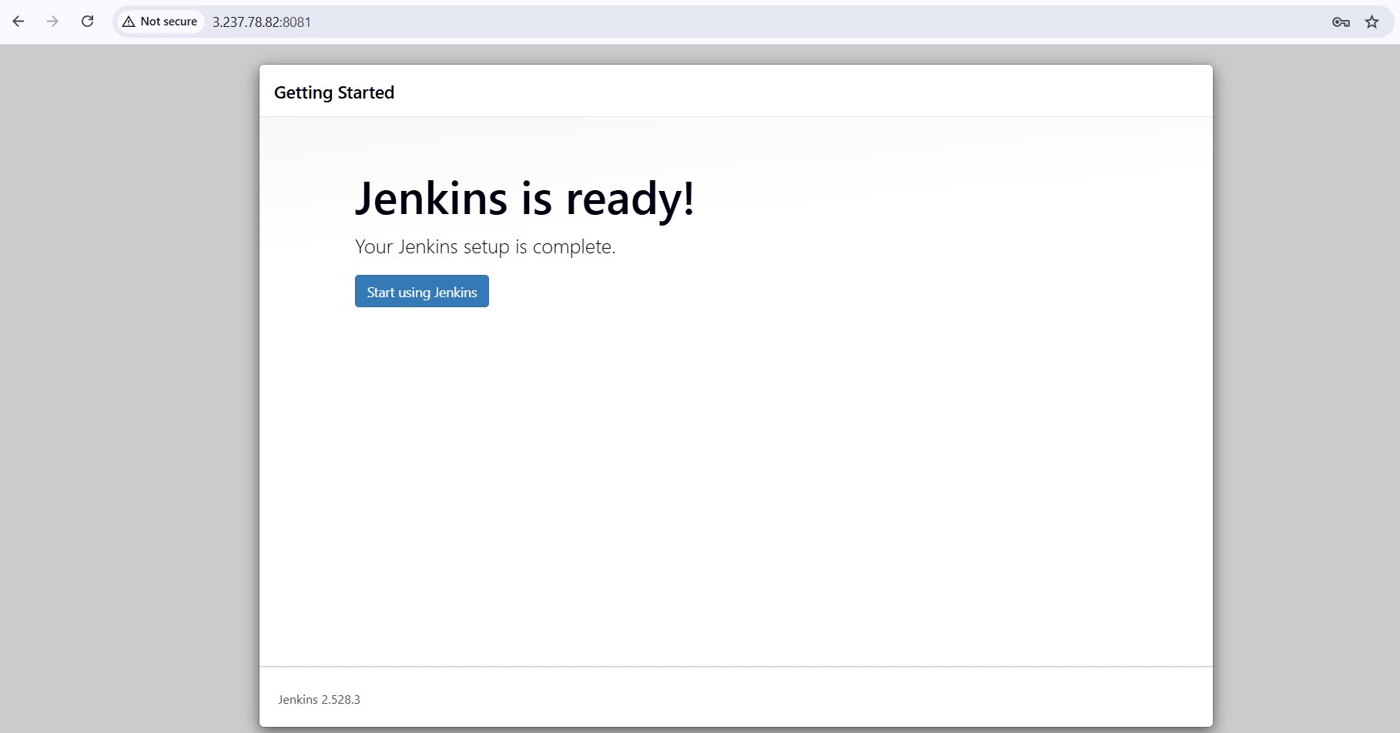
- Clicked Start using Jenkins.
- Successfully accessed the Jenkins dashboard, confirming secure setup completion.
Validation steps:
- Jenkins Unlock screen displayed successfully
- Initial admin password retrieved without errors
- Recommended plugins installed successfully
- Admin user created successfully
- Jenkins URL configured correctly
- Jenkins dashboard accessible via browser
Conclusion
The Jenkins server was successfully secured and configured. The initial setup process was completed by unlocking Jenkins, installing essential plugins, creating an administrator account, and finalizing instance configuration. The Jenkins server is now ready for use in building and managing CI/CD pipelines securely.

Task Title
Create Users in Jenkins with Limited Access
Objective
The objective of this task is to create multiple users in Jenkins and restrict their access using role-based permissions. This ensures secure access control by granting only the required privileges to non-admin users while maintaining full control for the administrator.
Prerequisites
- Jenkins server installed and running
- Administrator access to Jenkins
- Jenkins security enabled
- Browser access to Jenkins dashboard
Steps Performed
- Logged in to the Jenkins dashboard with administrator privileges.
- Navigated to Manage Jenkins from the home page.
- Selected Users under the Security section.
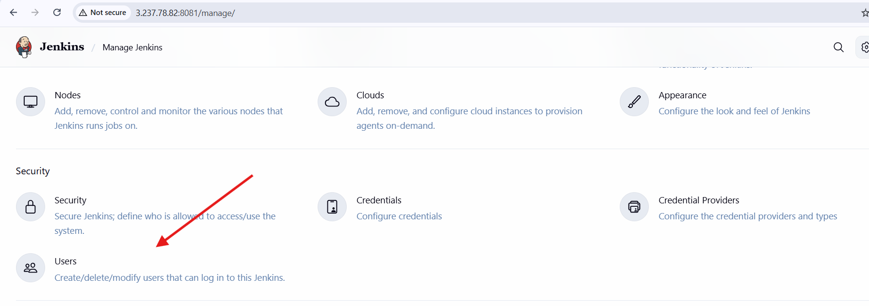
- Created two Jenkins users named:
  - devops-01
  - Testing
- Verified that the newly created users appeared in the Jenkins user list.
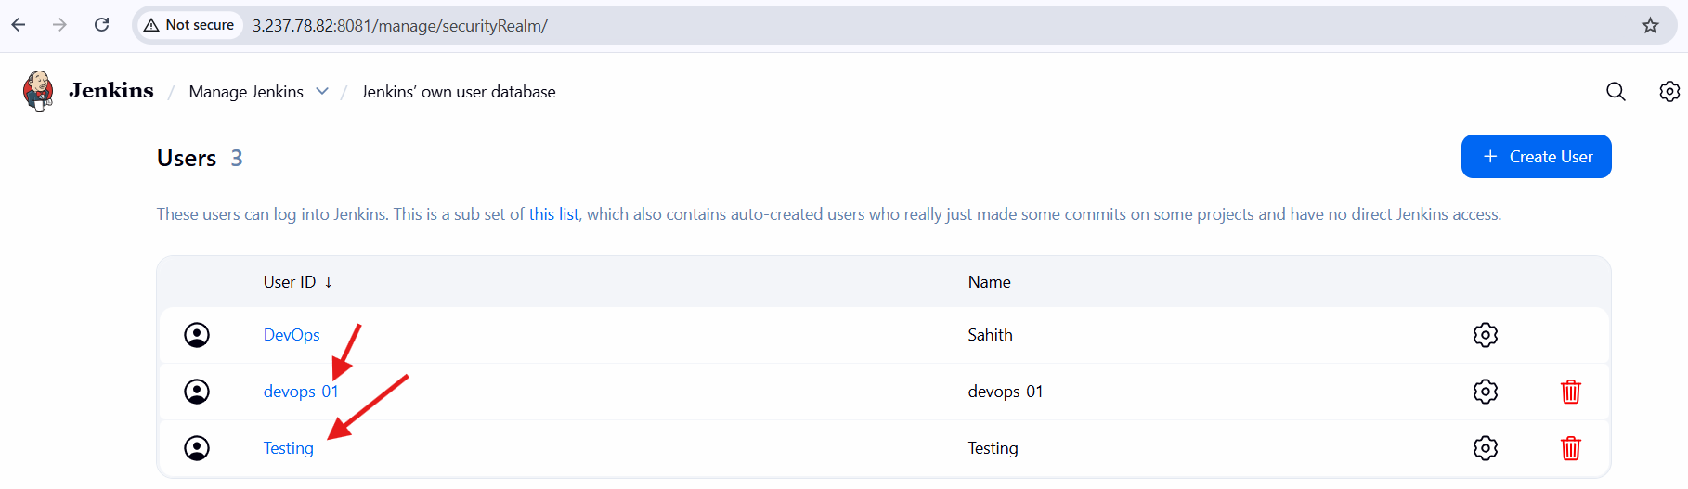
- Returned to Manage Jenkins.
- Opened Security configuration.
- Selected Project-based Matrix Authorization Strategy.
- Added devops-01 and Testing users to the authorization matrix.
- Assigned limited permissions to both users as required.
- Ensured full permissions were granted only to the administrator account.
- Reviewed permission assignments for accuracy.
- Saved the security configuration.
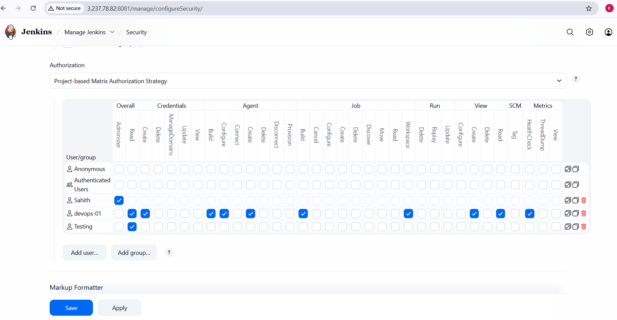
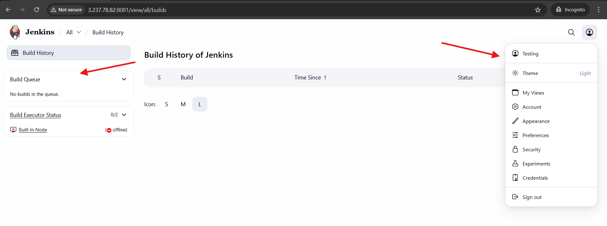
Validation steps:
- Verified that both users were created successfully in Jenkins.
- Confirmed users appeared in the Jenkins user management list.
- Verified limited access was applied to devops-01 and Testing.
- Confirmed administrator retained full access.
- Logged in using limited-access users to confirm restricted permissions.
Conclusion
Jenkins users devops-01 and Testing were successfully created and configured with limited access. By applying the Project-based Matrix Authorization Strategy, access control was implemented effectively, enhancing Jenkins security while allowing users to perform only their permitted actions. The Jenkins server is now more secure and follows best practices for user management.

Task Title
Configure Jenkins Plugins and Node Monitoring
Objective
The objective of this task is to enhance Jenkins functionality by managing plugins and configuring node settings. This includes verifying required plugins, monitoring plugin installation status, configuring system settings, and enabling disk and resource monitoring on the Jenkins built-in node to ensure stable and reliable job execution.
Prerequisites
- Jenkins server installed and running
- Administrator access to Jenkins
- Jenkins web UI accessible via browser
- Internet connectivity for plugin installation
Steps Performed – Jenkins Plugin and Node Configuration
- Logged in to the Jenkins dashboard using administrator access.
- Navigated to Manage Jenkins from the Jenkins home page.

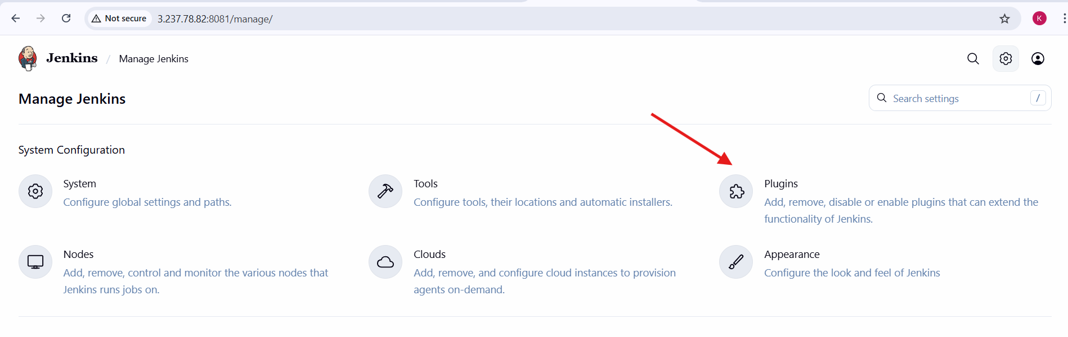
Plugin Management
- Selected Plugins under System Configuration.
- Opened the Installed Plugins section.
- Searched for plugins related to node.
- Verified that the Node and Label Parameter Plugin was installed and enabled.
- Verified installation of required Pipeline plugins.
- Navigated to Download Progress to monitor plugin installation.
- Confirmed that all selected plugins were installed successfully with no errors.
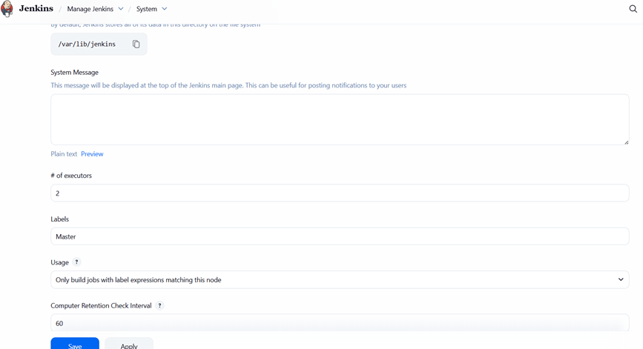
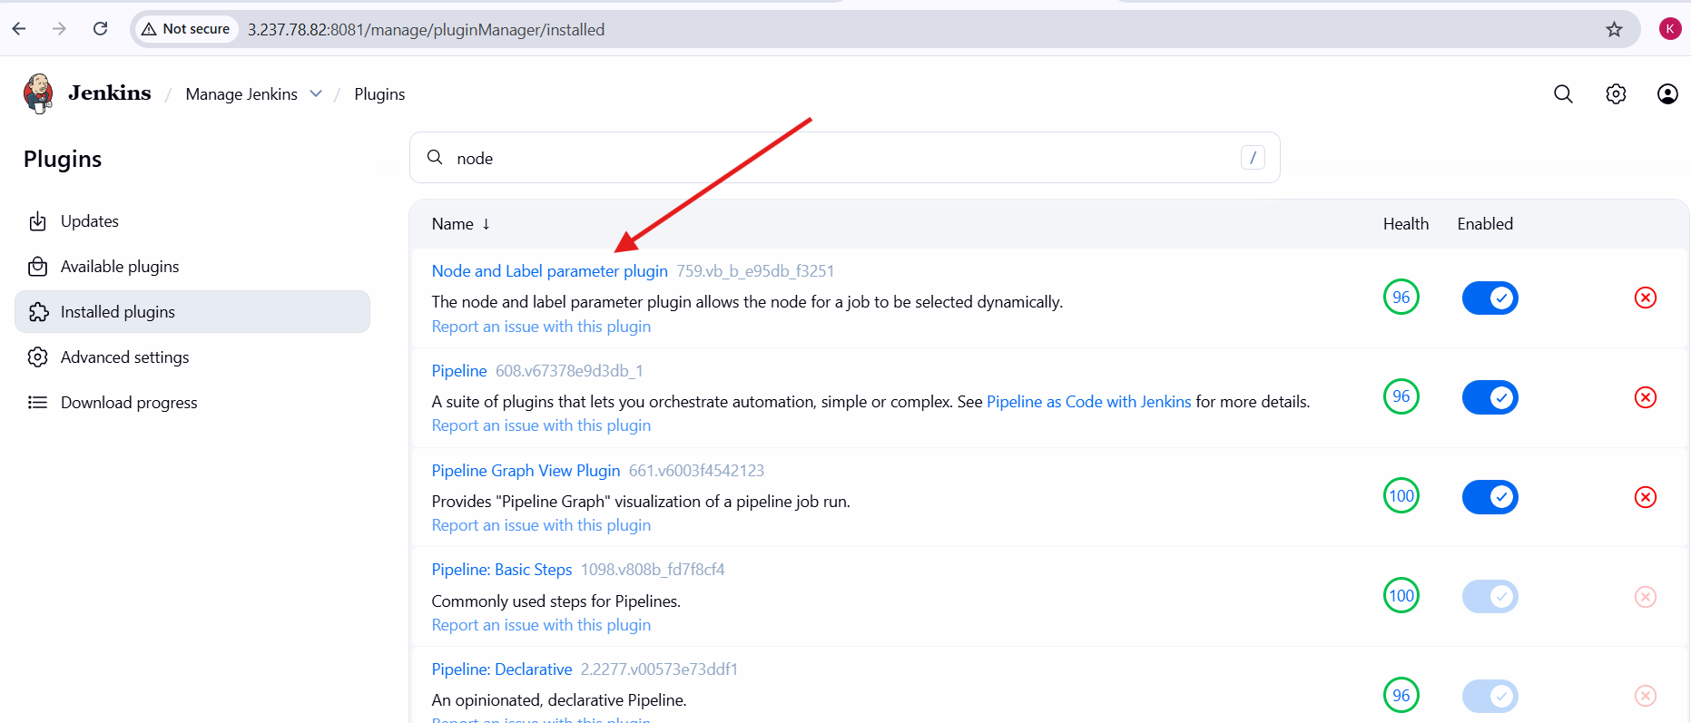

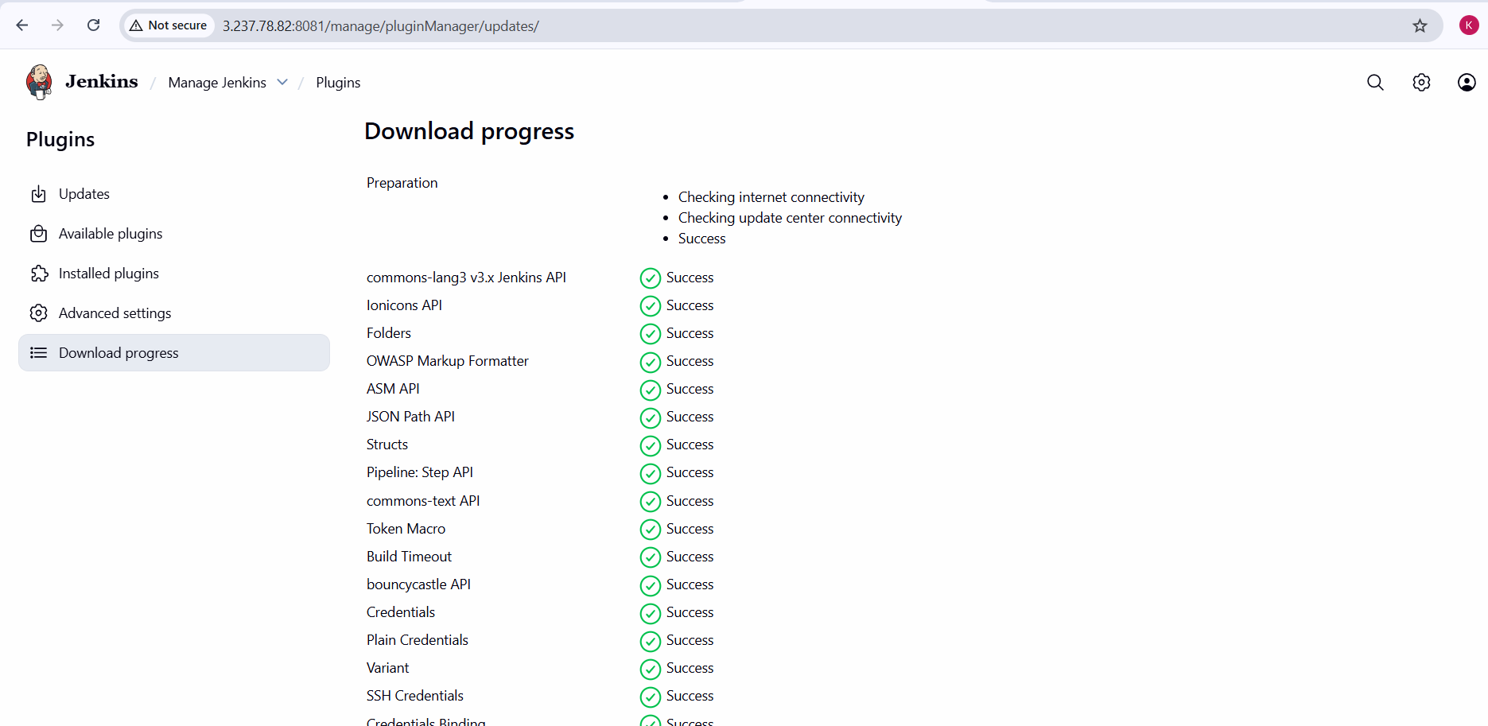

System Configuration
- Navigated to Manage Jenkins → System.
- Reviewed Jenkins home directory configuration.
- Verified executor settings and node usage configuration.
- Saved the system configuration settings.
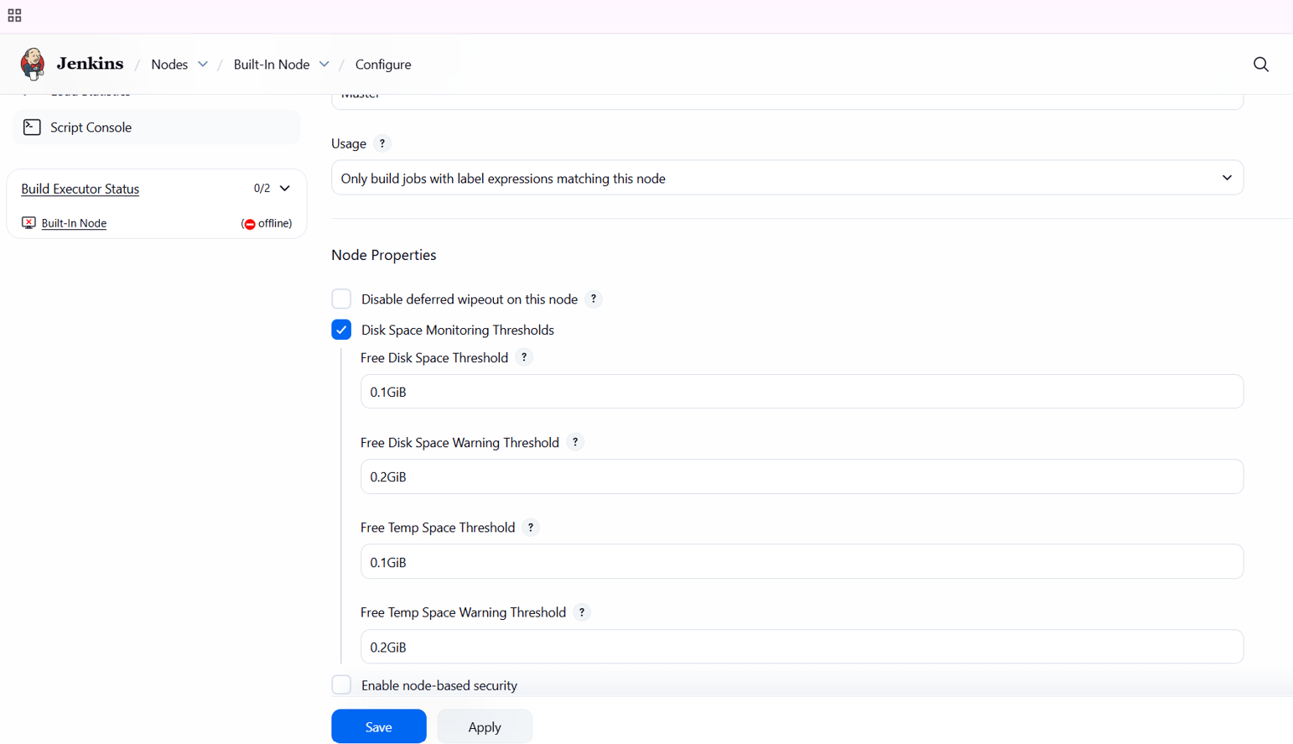
Node Configuration
- Navigated to Manage Jenkins → Nodes.
- Selected Built-In Node.
- Opened the Configure option for the built-in node.
- Configured node usage to allow jobs based on label expressions.
- Enabled Disk Space Monitoring Thresholds.
- Configured disk space and temporary space warning thresholds.
- Saved the node configuration.
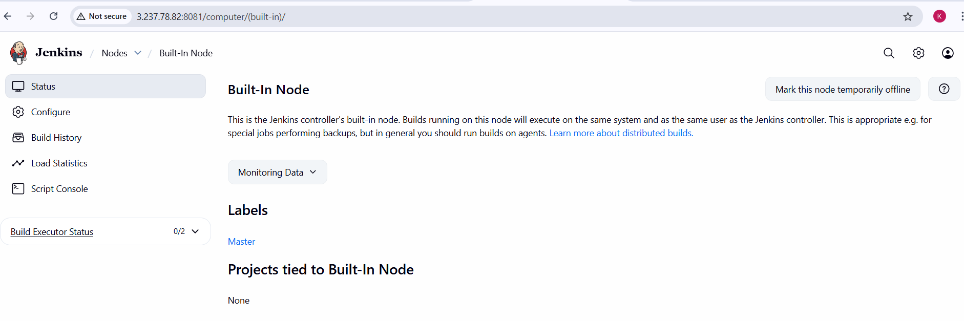
Node Monitoring
- Navigated back to the Nodes overview page.
- Verified the built-in node status and architecture details.
- Checked monitoring data such as:
  - Free disk space
  - Free swap space
  - Free temporary space
  - Response time
- Confirmed that node monitoring data was being collected successfully.
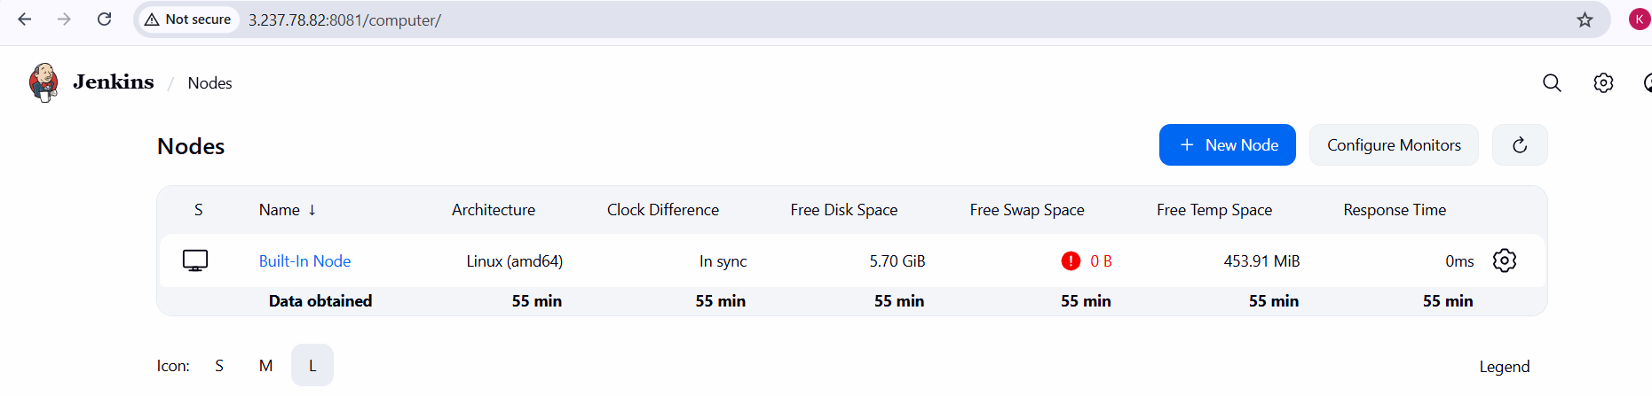
Validation:
- Plugins appeared in the installed plugins list and were enabled
- Plugin download progress completed without errors
- System configuration changes saved successfully
- Disk and resource monitoring enabled on built-in node
- Node monitoring data displayed correctly in Jenkins
Conclusion:
Jenkins plugins and node configurations were successfully managed and verified. Required plugins were installed and enabled, system settings were reviewed, and monitoring thresholds were configured on the built-in node. These configurations improve Jenkins stability, monitoring, and readiness for executing CI/CD pipelines efficiently.

Task Title
Create Jenkins Jobs Using Public and Private GitHub Repositories
Objective
The objective of this task is to create and execute multiple Jenkins Freestyle jobs using both a public and a private GitHub repository. This includes configuring Jenkins jobs to pull source code from a public repository, creating multiple sample jobs, integrating Jenkins with a private GitHub repository using a Personal Access Token (PAT), handling authentication errors, and validating successful builds through console output.
Prerequisites
- Jenkins server installed and running
- Administrator access to Jenkins
- Git plugin installed in Jenkins
- Internet connectivity from Jenkins server
- GitHub account
- Access to a private GitHub repository
- GitHub Personal Access Token (PAT)
Task 1: Create Three Sample Jenkins Jobs Using Public GitHub Repository
Repository URL:
https://github.com/betawins/Techie_horizon_Login_app.git
Steps Performed
- Logged in to the Jenkins dashboard.
- Created a new Jenkins Freestyle job.
- Configured Source Code Management using Git.
- Entered the public GitHub repository URL.
- Saved the job configuration.
- Triggered the build using Build Now.
- Verified successful code checkout and build completion.
- Repeated the same steps to create three separate sample Jenkins jobs using the same public GitHub repository.
- Verified that all three jobs executed successfully.

Task 2: Create Jenkins Job Using Private GitHub Repository
Steps Performed
- Created a new Jenkins Freestyle job named jenkins-Privgit.
- Generated a GitHub Personal Access Token (classic) from GitHub Developer Settings.
- Saved the token securely.
- Configured Source Code Management in Jenkins.
- Selected Git and entered the private GitHub repository URL.
- Added GitHub credentials in Jenkins using:
  - Username
  - Personal Access Token as the password
- Selected the configured credentials for the job.
- Saved the job configuration.
Steps Performed – Create and Run Jenkins Freestyle Job
- Logged in to the Jenkins dashboard.
- Clicked New Item from the Jenkins home page.
- Entered the job name as jenkinsTask.
- Selected Freestyle project as the job type.
- Clicked OK to create the job.
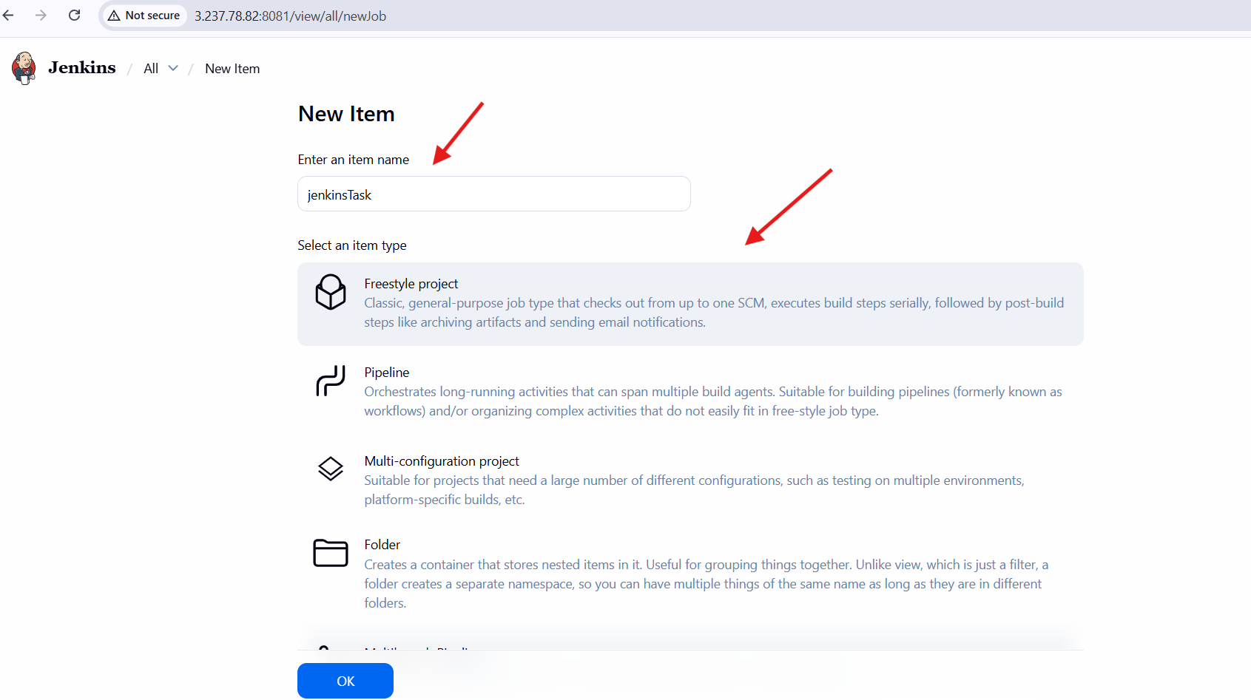
- Navigated to Source Code Management.
- Selected Git as the source code management option.
- Entered the GitHub repository URL.
- Left credentials as none.
- Saved the source code configuration.
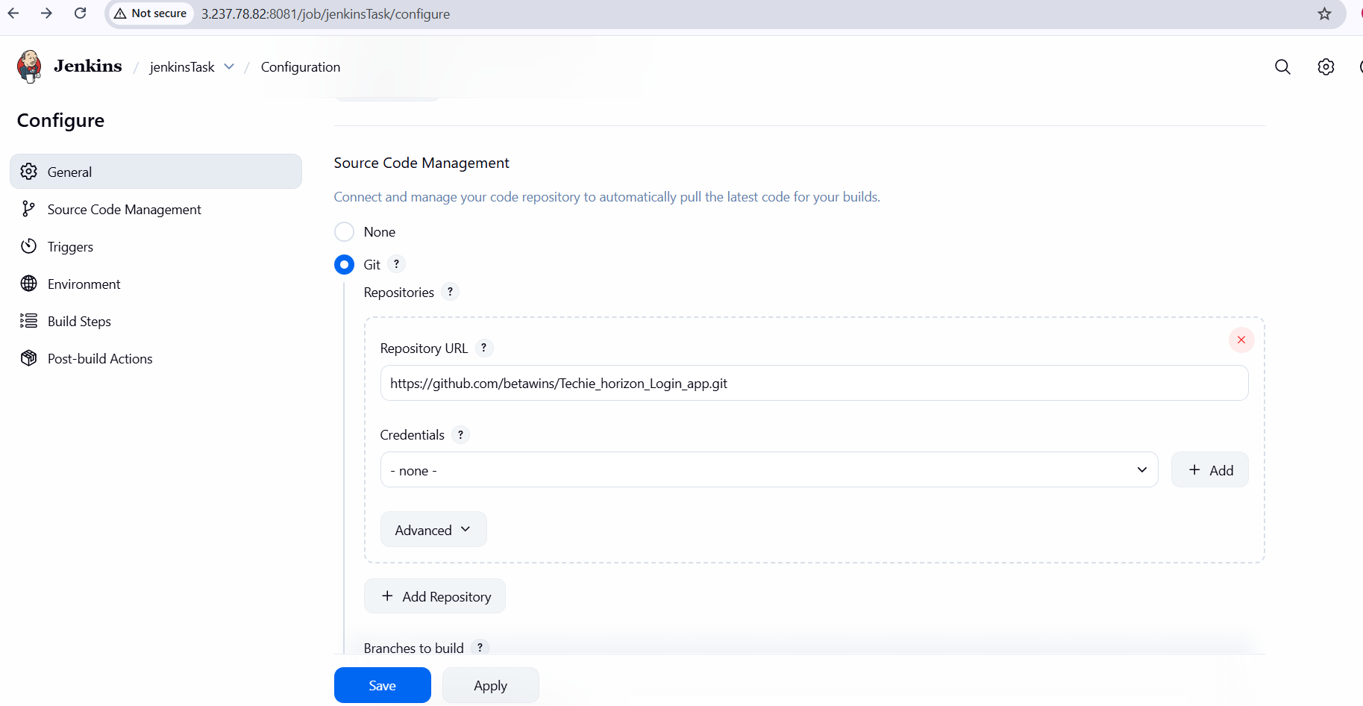
- Opened the Configuration page for the job.
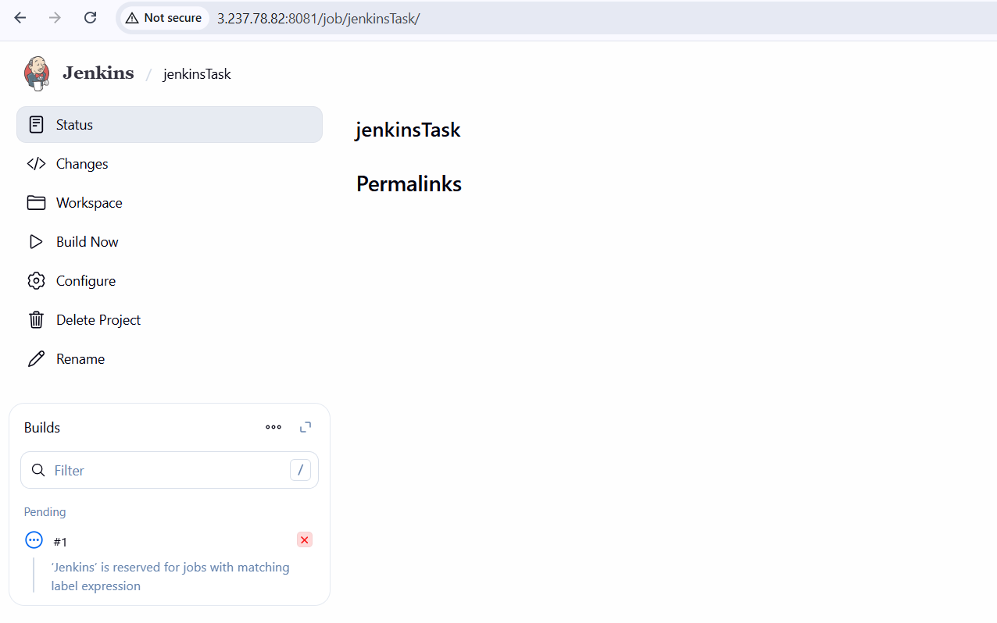
- Navigated to the General section.
- Enabled Restrict where this project can be run.
- Entered the label expression as Master.
- Saved the job configuration.
- Returned to the job dashboard.
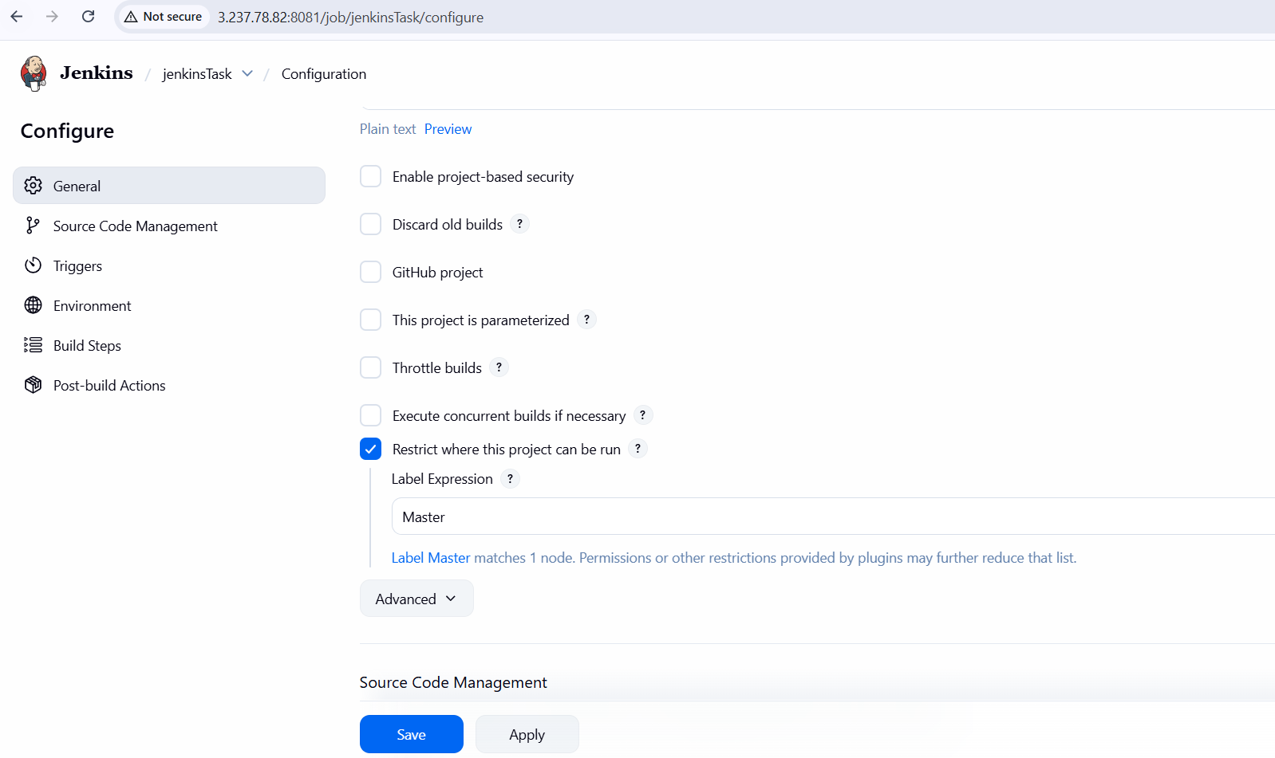
- Clicked Build Now to trigger the build.
- Observed the build appearing in the Builds section.
- Verified that the build completed successfully.
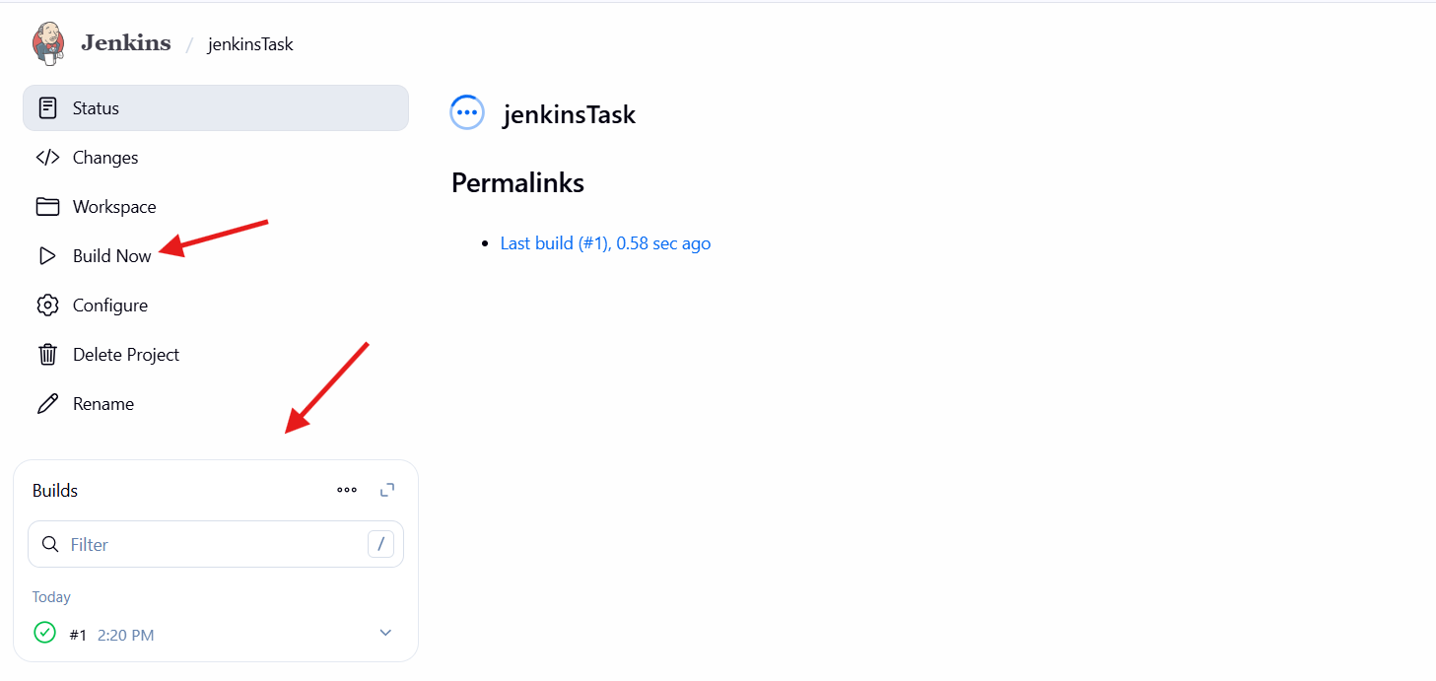
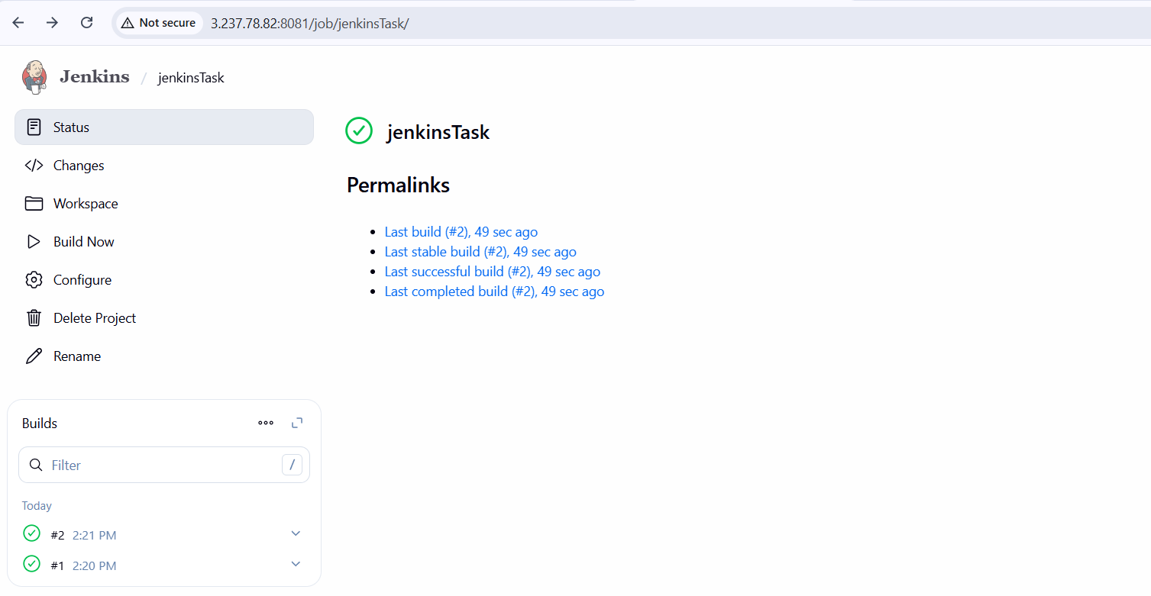
- Opened the Console Output for the completed build.
- Verified Git repository connection and code checkout.
- Confirmed that the build finished with SUCCESS status
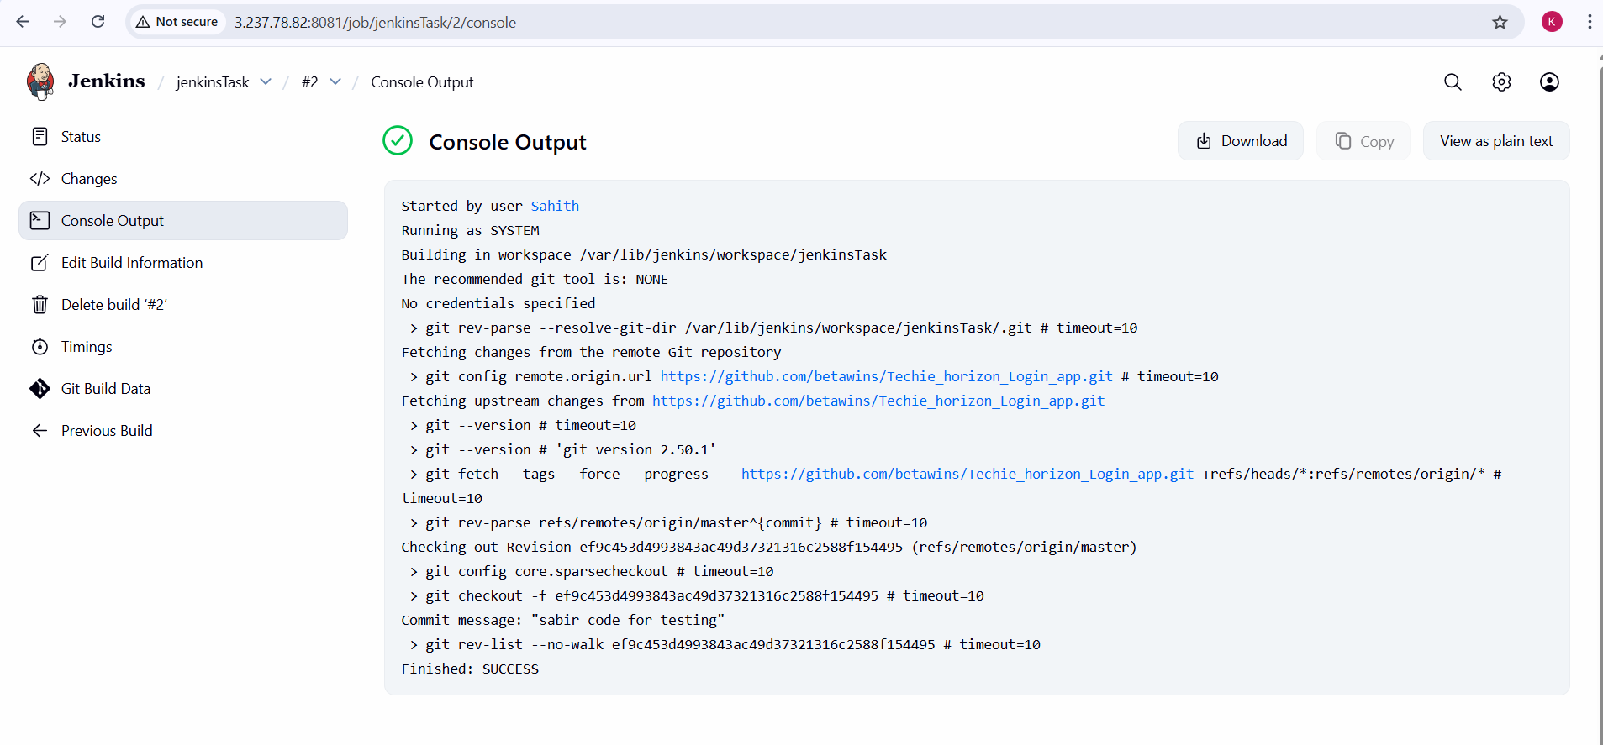

Task Title
Create one Jenkins job using git hub Private repository.
Objective
The objective of this task is to configure a Jenkins Freestyle job to securely access and build source code from a private GitHub repository. This includes generating a GitHub personal access token, configuring Jenkins credentials, handling initial build failures, and successfully validating repository access through a successful Jenkins build.
Prerequisites
- Jenkins server installed and running
- Administrator access to Jenkins
- Git plugin installed in Jenkins
- GitHub account with access to a private repository
- Internet connectivity from Jenkins server
- Personal Access Token (PAT) generated from GitHub

Steps Performed – Jenkins Freestyle Job with Private GitHub Repository
- Logged in to the Jenkins dashboard.
- Clicked New Item from the Jenkins home page.
- Entered the job name as jenkins-Privgit.
- Selected Freestyle project as the job type.
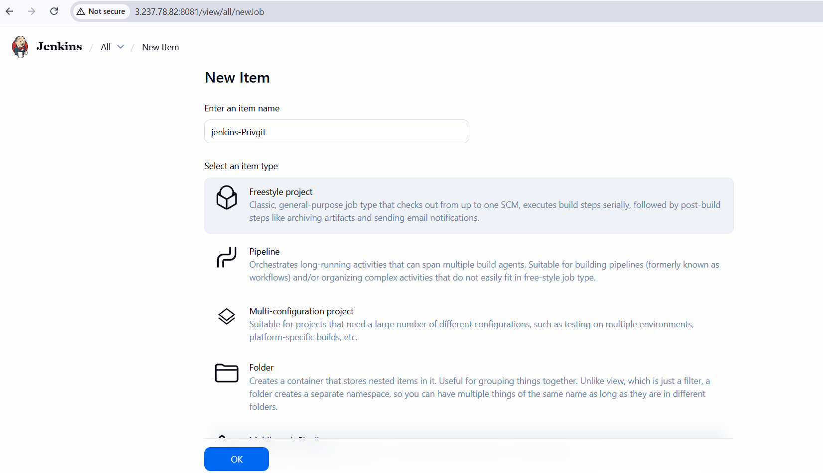
- Clicked OK to create the job.
- Opened GitHub Developer Settings.
- Navigated to Personal access tokens (classic).
- Generated a new personal access token.
- Copied and saved the generated GitHub token.
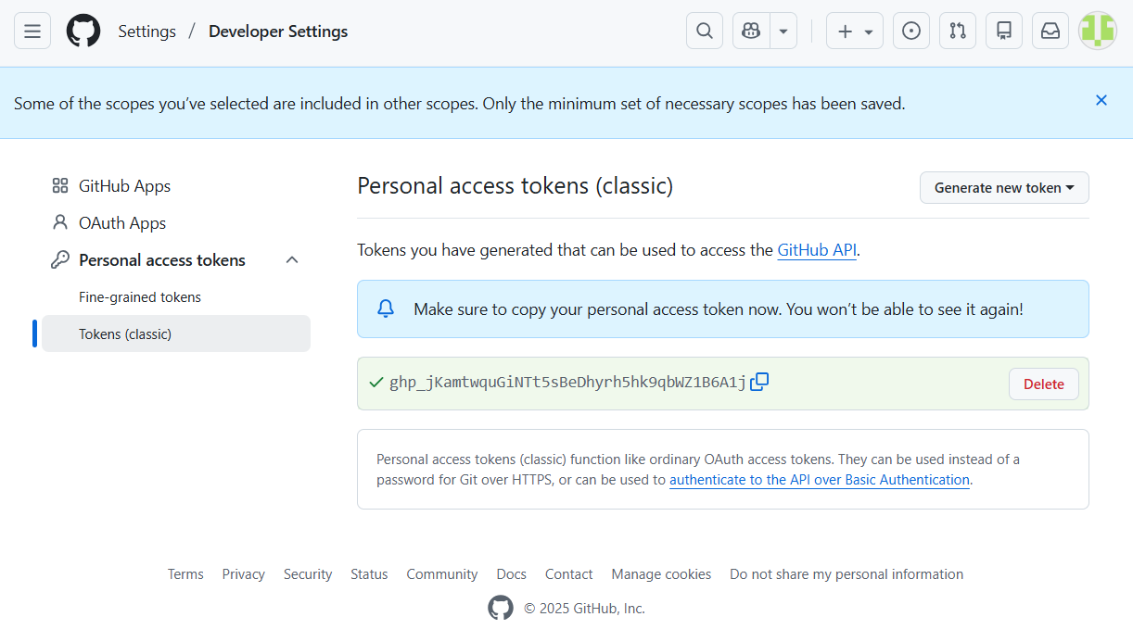
- Opened the Configuration page of the Jenkins job.
- Navigated to Source Code Management.
- Selected Git as the SCM option.
- Entered the private GitHub repository URL.
- Added GitHub credentials using the personal access token.
- Selected the saved credentials for repository access.
- Saved the job configuration.
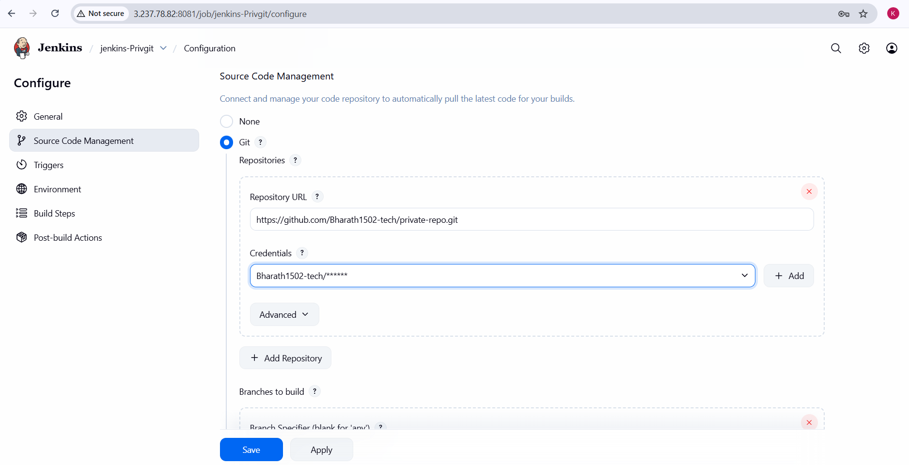
- Triggered the first build using Build Now.
- Observed the build failure due to initial configuration or credential validation.
- Updated or verified GitHub credentials in job configuration.
- Triggered the build again using Build Now.
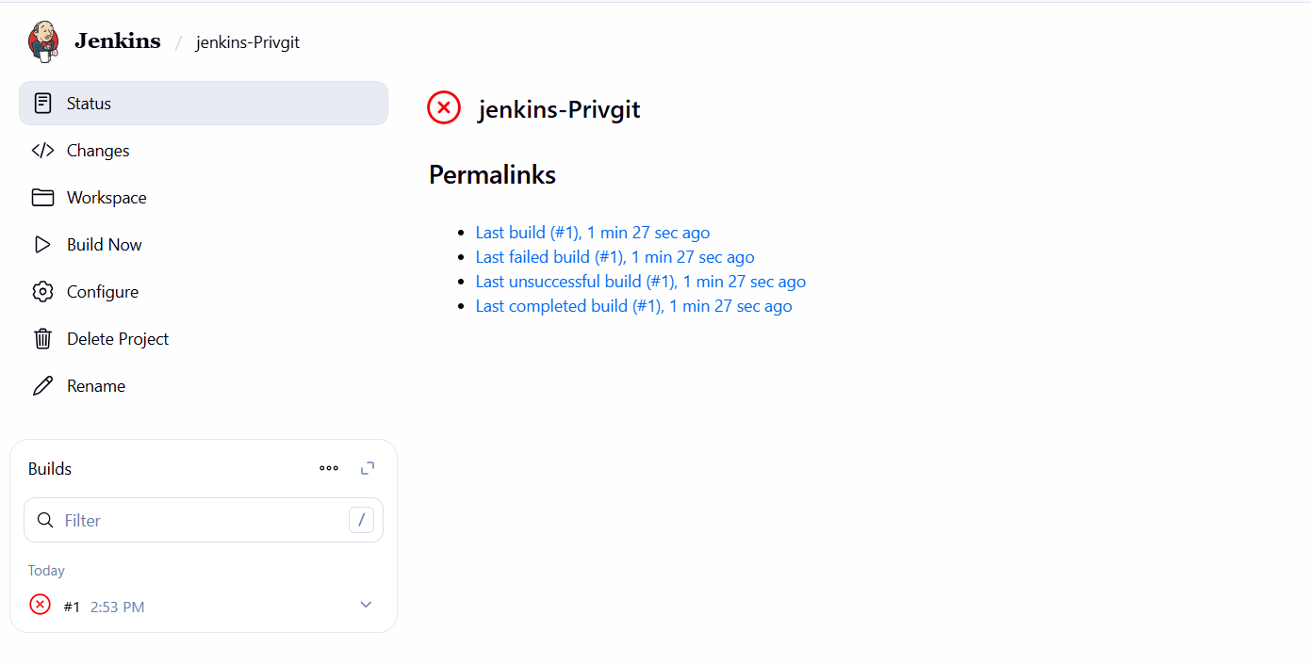
- Observed the build completing successfully.
- Opened the Console Output for the successful build.
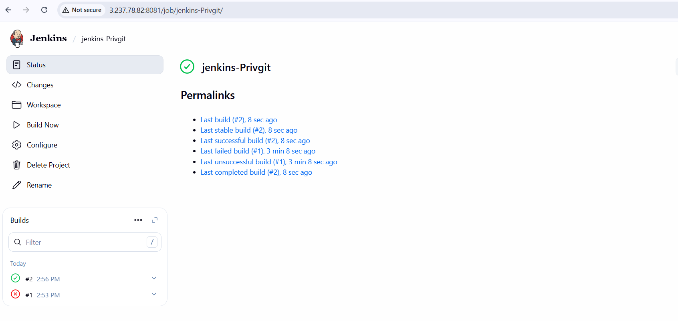
- Verified Git authentication using credentials.
- Confirmed repository fetch, checkout, and commit details.
- Verified build finished with SUCCESS status.

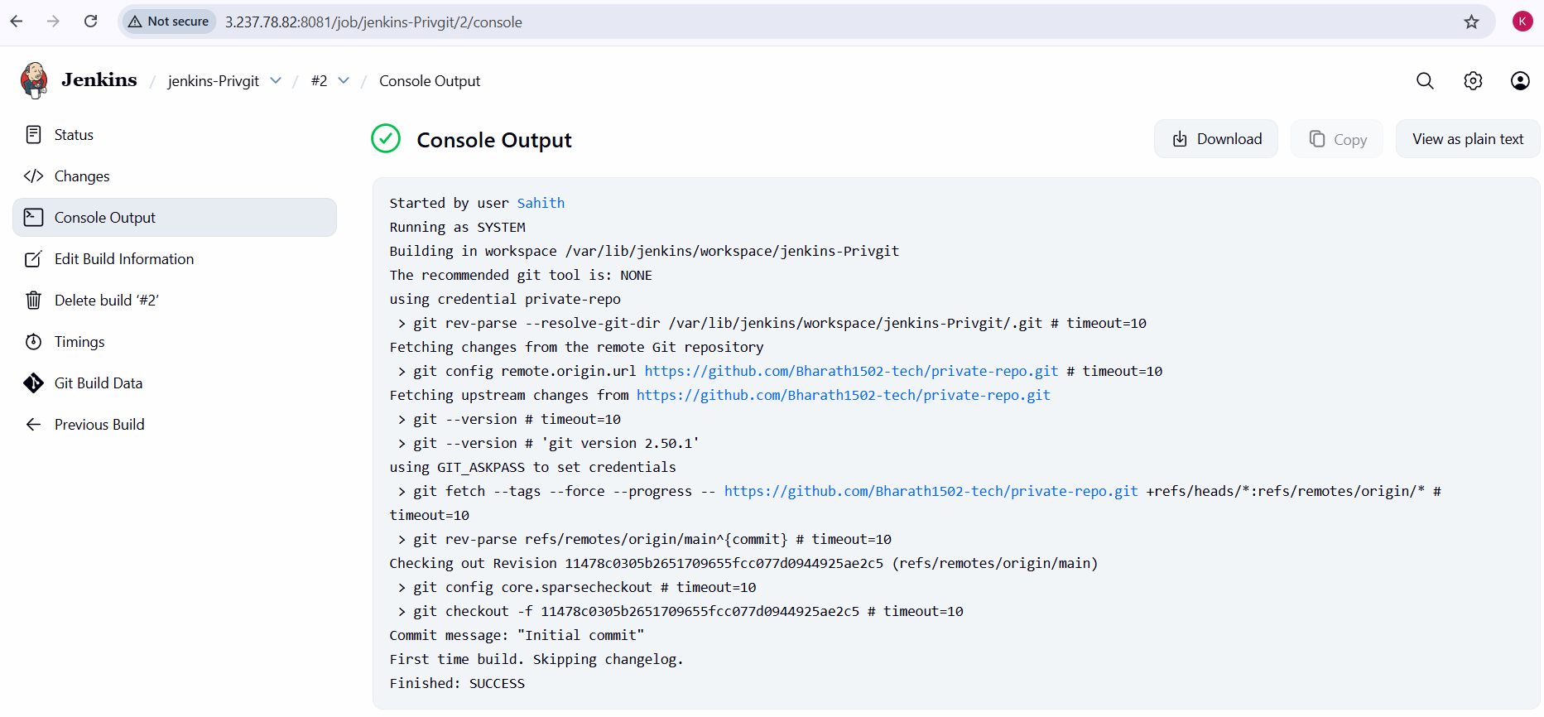
Error Steps (Private Repository Job)
- Triggered the initial build using Build Now.
- Build failed due to authentication or credential configuration issues.
- Jenkins was unable to access the private GitHub repository.

Resolution
- Verified the GitHub Personal Access Token.
- Corrected Jenkins credential configuration.
- Re-selected the correct credentials in the job configuration.
- Saved the updated configuration.
Successful Execution
- Triggered the build again after correcting credentials.
- Jenkins successfully authenticated with the private GitHub repository.
- Source code was fetched and checked out successfully.
- Build completed with SUCCESS status.
Validation
- Three Jenkins jobs created using the public GitHub repository
- All public repository jobs built successfully
- Jenkins job created for private GitHub repository
- GitHub Personal Access Token configured correctly
- Initial authentication error identified and resolved
- Successful build confirmed through Jenkins console output
Conclusion
Multiple Jenkins Freestyle jobs were successfully created and executed using both public and private GitHub repositories. Public repository integration required no authentication and executed smoothly across multiple jobs. Private repository integration was securely configured using a GitHub Personal Access Token, with initial authentication issues resolved successfully. This task demonstrates Jenkins’ capability to handle both public and private source code repositories for CI/CD workflows.

Overall Task Conclusion:
Jenkins was successfully installed and configured to run on a custom port (8081). The Jenkins server was secured through initial setup, plugin installation, and administrator configuration. Role-based access control was implemented by creating limited-access users (DevOps and Testing) using matrix authorization. Node labels were configured to restrict job execution to specific nodes, ensuring controlled and predictable builds.
Multiple Jenkins jobs were created using a public GitHub repository, demonstrating seamless integration without authentication. Additionally, a Jenkins job was securely integrated with a private GitHub repository using a Personal Access Token, with authentication issues resolved successfully. Overall, this task demonstrates a complete Jenkins CI setup following best practices for security, access control, and source code integration.

